Introduction

The purpose of this study is to record the overall experience of joining Yelp as a business owner. Specifically, the completion of a Yelp business profile, creation of a Yelp advertising campaign, and executing & measuring the results of Yelp’s $300 Free Trial.

The business used to conduct this study is www.TheOrganizedCouple.com, which is a service-based business in the Home Organization industry. The Yelp business profile for The Organized Couple had no activity or reviews prior to conducting this study.

Table of Contents
Introduction 1
Table of Contents 1
Experience signing up and creating a Yelp ad 2
Ad creation 2
Monitoring your campaign 9
Historical metrics 12
Strategy & Results from $300 Free Yelp Ads Trial 13
Our plan for Yelp moving forward 14
Conclusion 14

Experience signing up and creating a Yelp ad

The experience signing up for Yelp itself was very easy. They ask you to claim your profile by searching for your business using their tool (if you have a business profile already then you just select that search result, and if not, it prompts you to create a profile).

They do provide you with some basic tips on what type of information to include in your business description/specialties. In my opinion, they could elaborate on this a little more as it’s an essential part of how customers really learn what your business is about, and deciding if you are the one they want to work with. I took a little extra time and was able to easily find more detailed recommendations and examples by doing a quick Google search.

After writing the business description, you’re prompted to upload photos and provide other business information such as hours, location, phone, email, etc..

They do limit what you can do on the profile for free, such as the order in which photos are displayed. The only way to activate some of these features is to begin advertising, and even then, some others, such as Business Highlights, are an additional daily cost. These are all factors you need to think about when creating an ad and determining your budget.

Ad creation

Yelp provides you with five basic categories for creating your business ad: Keywords, Photos, Ad Copy, Radius, and Budget.

Keywords: Yelp provides you with a list of the keywords they will use to target leads based upon your business category. You cannot add your own keywords, which can be good or bad based upon your level of marketing experience. You’ll need to review these keywords and remove any keywords you think are not relevant to your market.

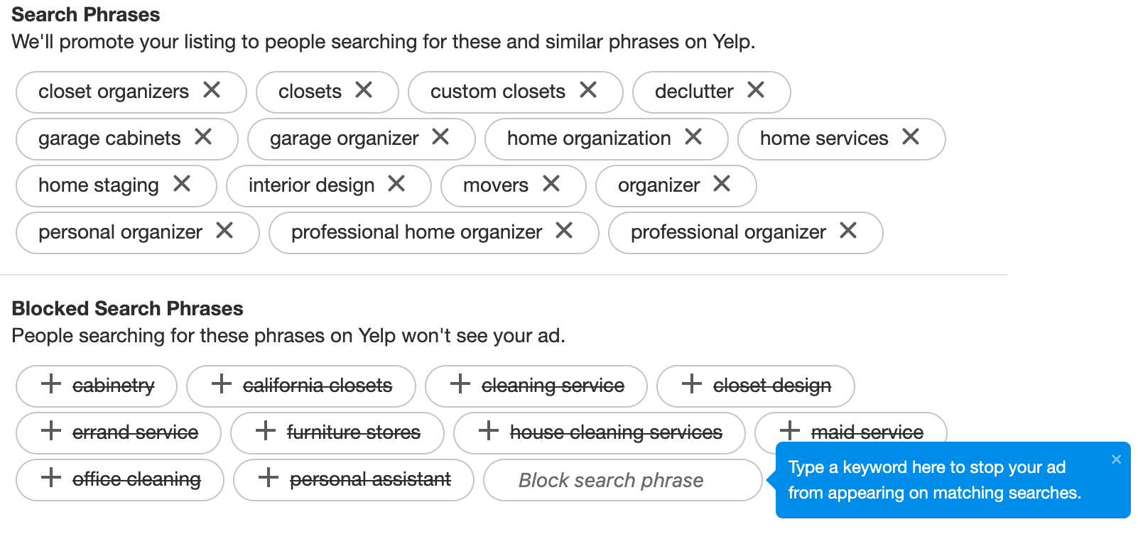

Ad copy: You’re able to either choose a review (if you have any) to display underneath your business information, or create your own ad copy. The first image below is an ad with a review as ad copy, and the second image is an ad with ad copy we created.

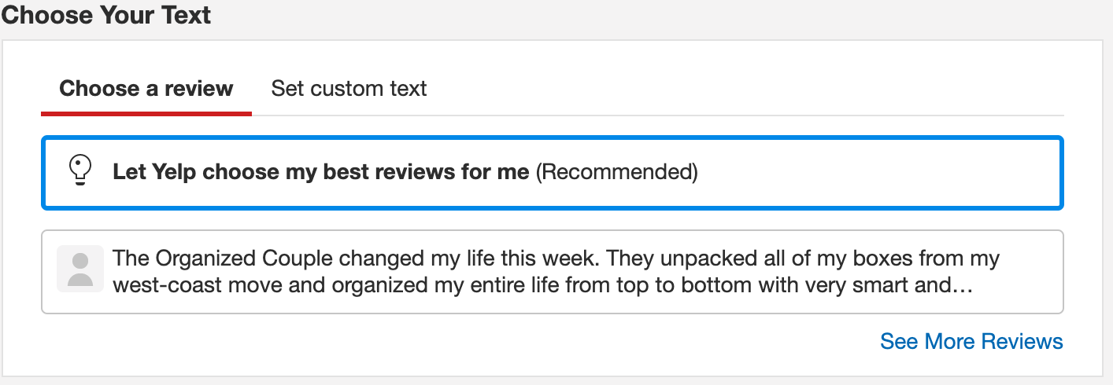
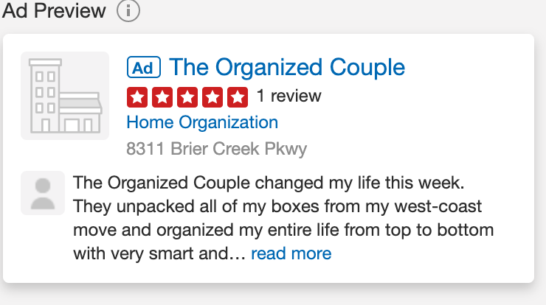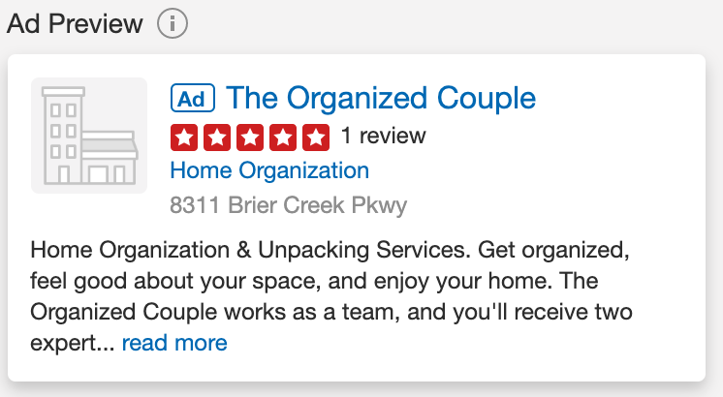

Photos: Next, you can upload photos and once you’ve activated an ad campaign, you can choose the order in which they’re displayed within your ads.

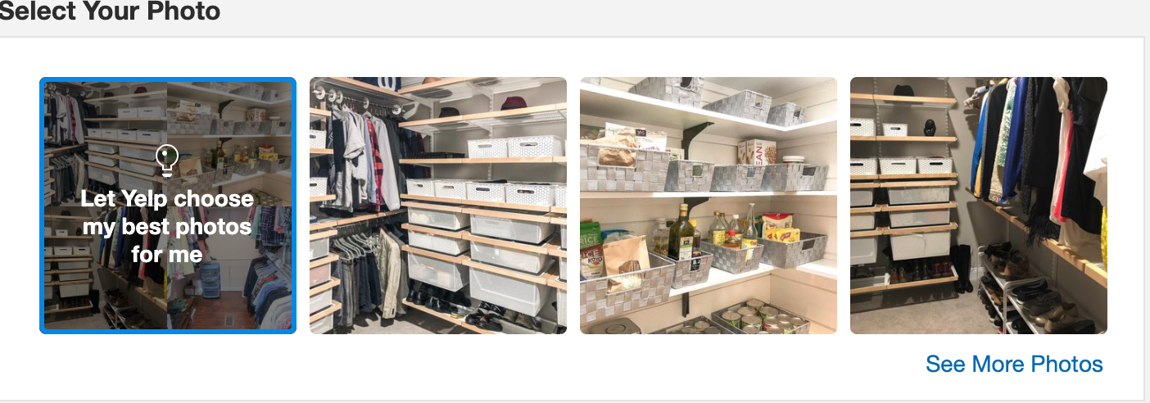

Radius: They give the options of 10, 15, or 25 miles radius to target users based upon your business address.
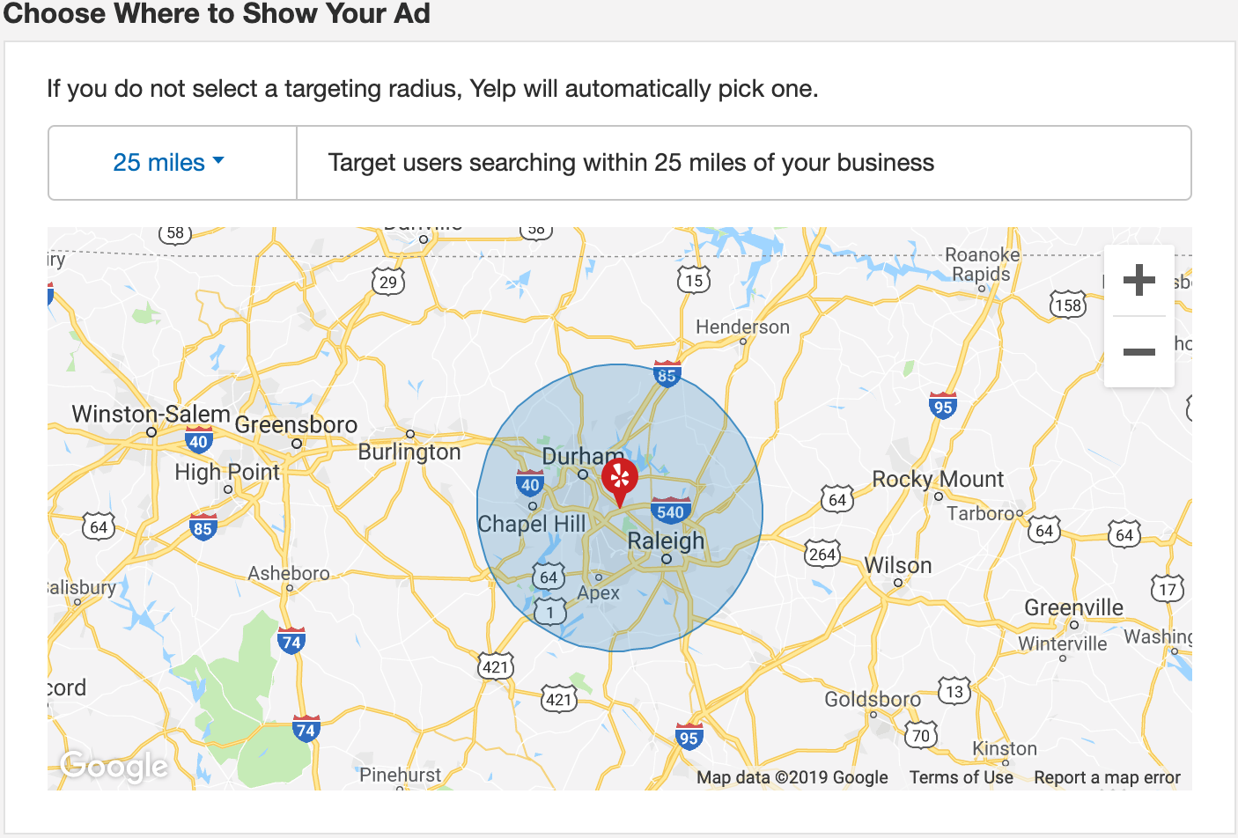

Budget: Once your ad is ready to go, you will select a daily budget and any upgrades you’d like, such as Business Page Upgrades, Business Highlights, or Portfolio.

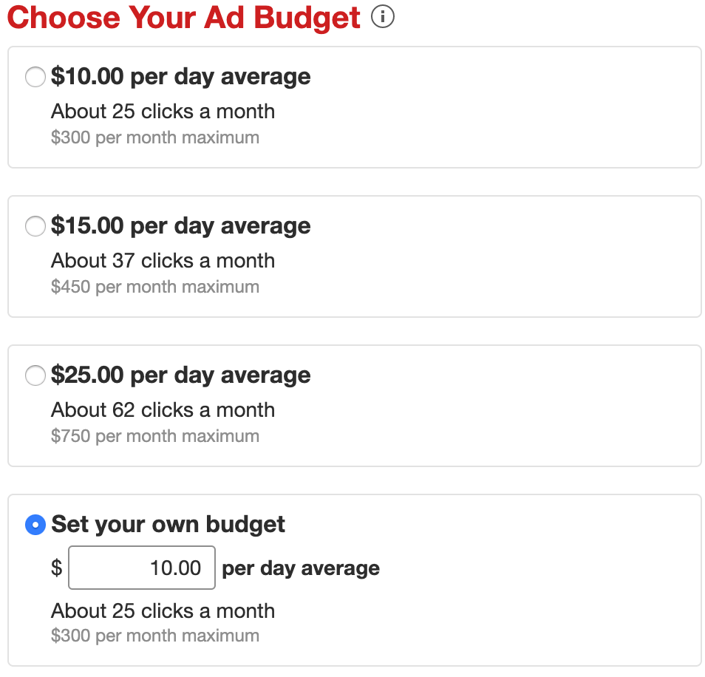
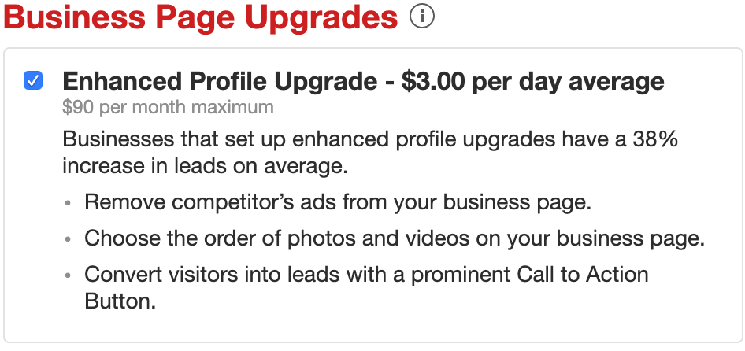
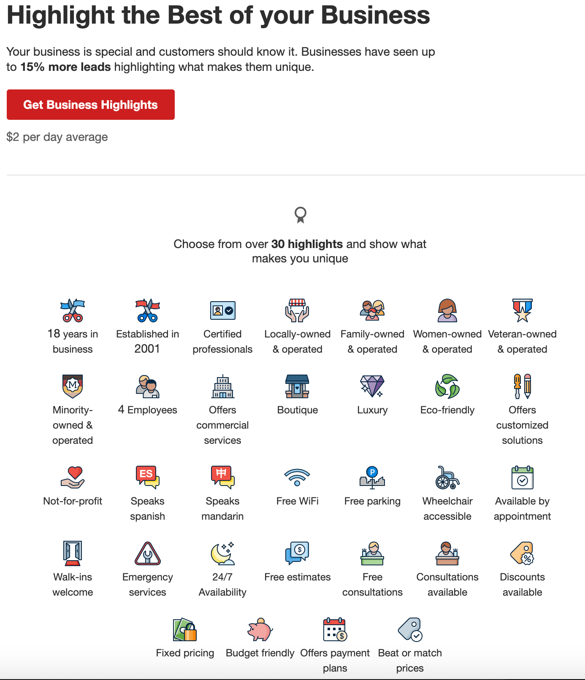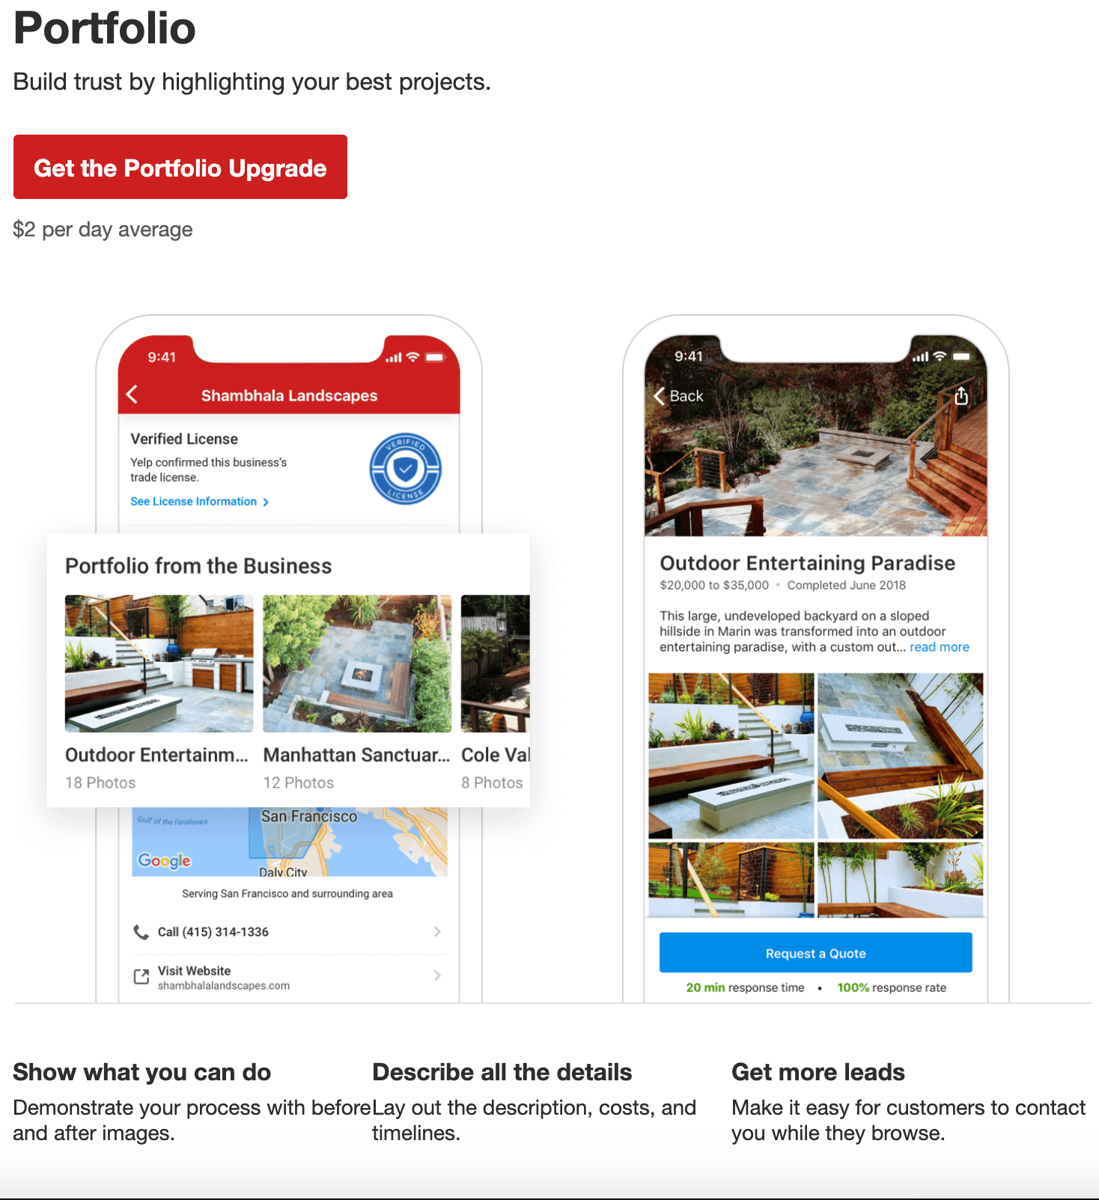

Monitoring your campaign

The biggest thing you can do to ensure your campaign is effective is to monitor your results, and make adjustments. Yelp provides you with some general statistics, including Views, Leads and Revenue Estimates.

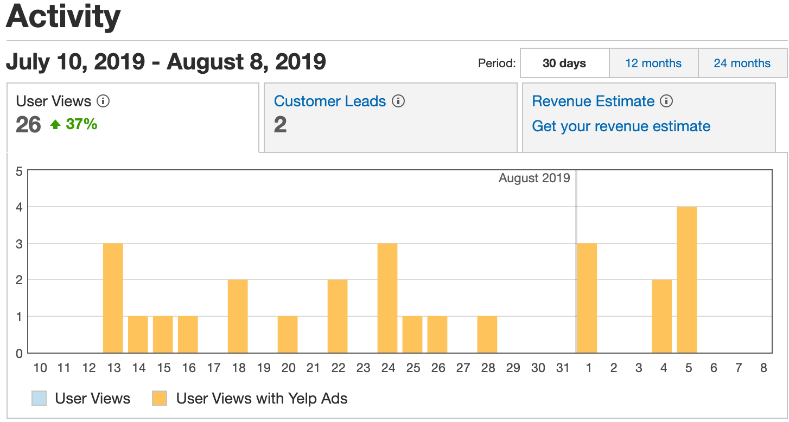

Views: 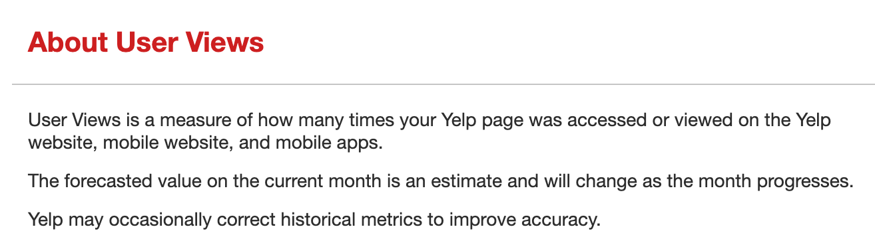

Leads: 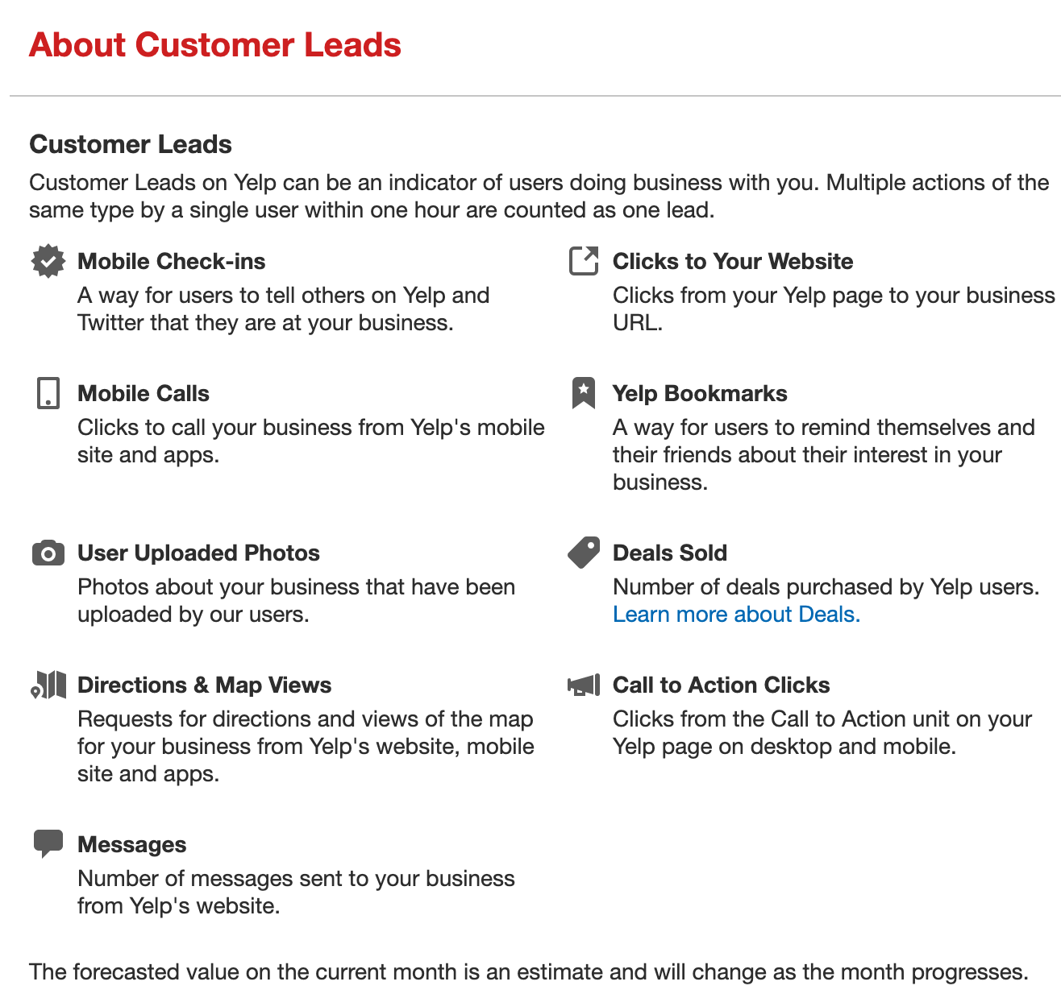

Estimated Revenue: 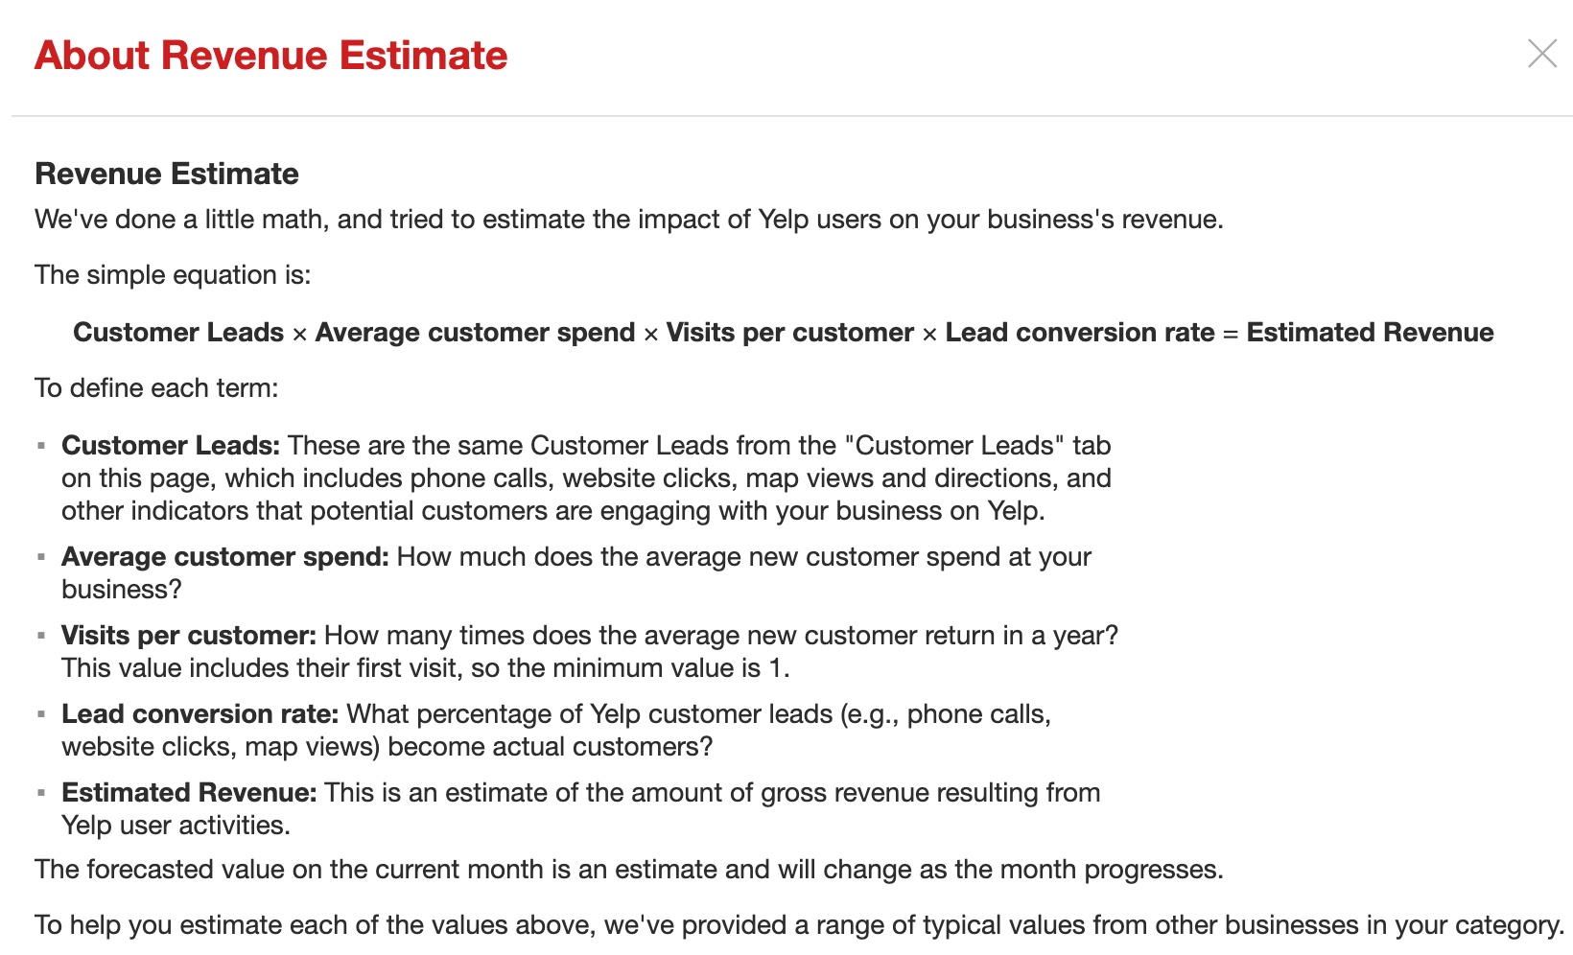

For most small business owners, the best metrics to pay attention to are views and leads. This will help you determine how many people are seeing your ads vs how many are contacting you.

The revenue estimation tool can be very misleading if not configured properly, so I would recommend working on that after you are more familiar with the tool.

The most accurate way you can determine the value of Yelp ads, or any advertising campaign, is to simply ask your customers how they found you. This can be done either by simply asking them when they call or visit your business, or by adding an option on your website contact forms.

Additionally, you can sign up for and configure Google Analytics which is very accurate at showing you where digital visitors came from, but it still will not tell you where they originated for phone calls (they do track Google paid ad phone conversions but will not show you a call from a Yelp user) and walk-ins.

One tip I have for measuring phone leads is to set up a new phone number for each platform you’re advertising on (using a cheap web phone, of course), so that when someone calls that specific number, you don’t have to ask how they heard about you, because they would have only gotten that number by viewing a campaign on a specific platform.

Historical metrics
In addition to the campaign monitoring tools described in the section above, Yelp provides you with a few industry standard tools to monitor your metrics. These are great benchmarks to help you understand the reach you are getting with your ad campaign, and how much a specific action (like a click on your ad) is costing you. The terms below are what most marketing platforms use to describe results so it’s very important to both understand and monitor these closely.

Definition of the metrics provided:
- Period: Time frame of the campaign metrics you are viewing
- Ad Impressions: How many times an ad was viewed
- Ad Clicks: Number of times an ad was actually clicked on by a user
- Cost Per Click: Total campaign cost during the selected time period divided by quantity of clicks in the same time period
- Ad Spend: Total amount spent during that time period

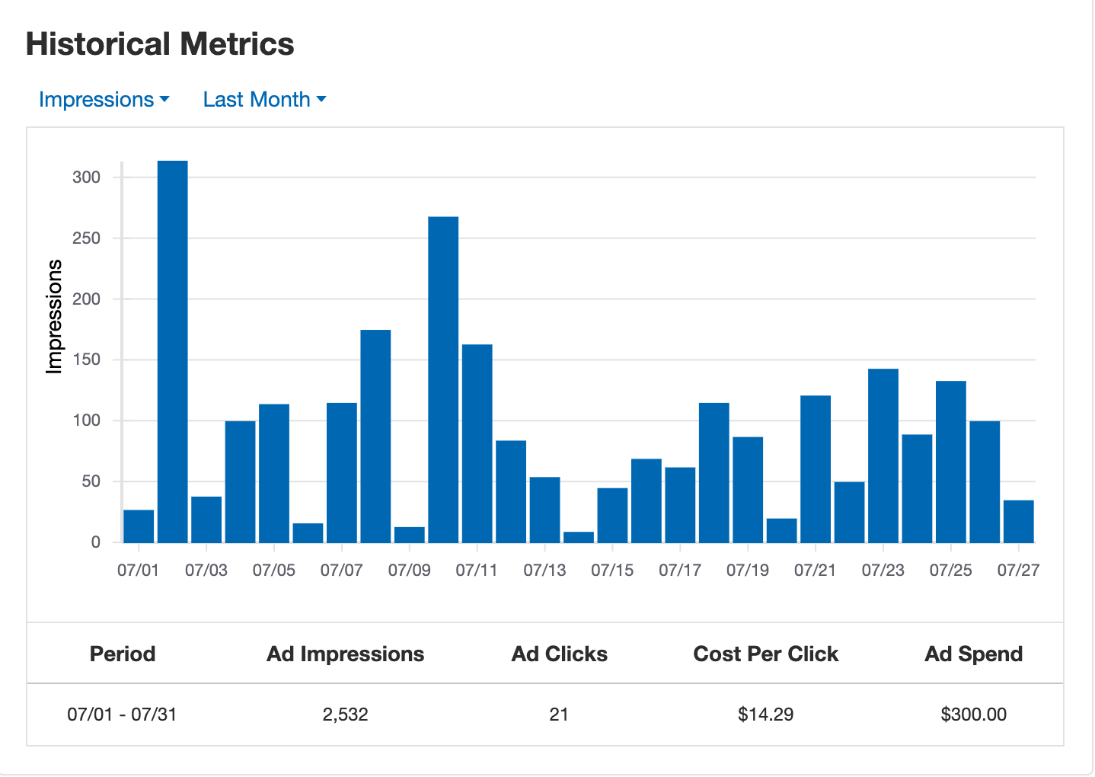
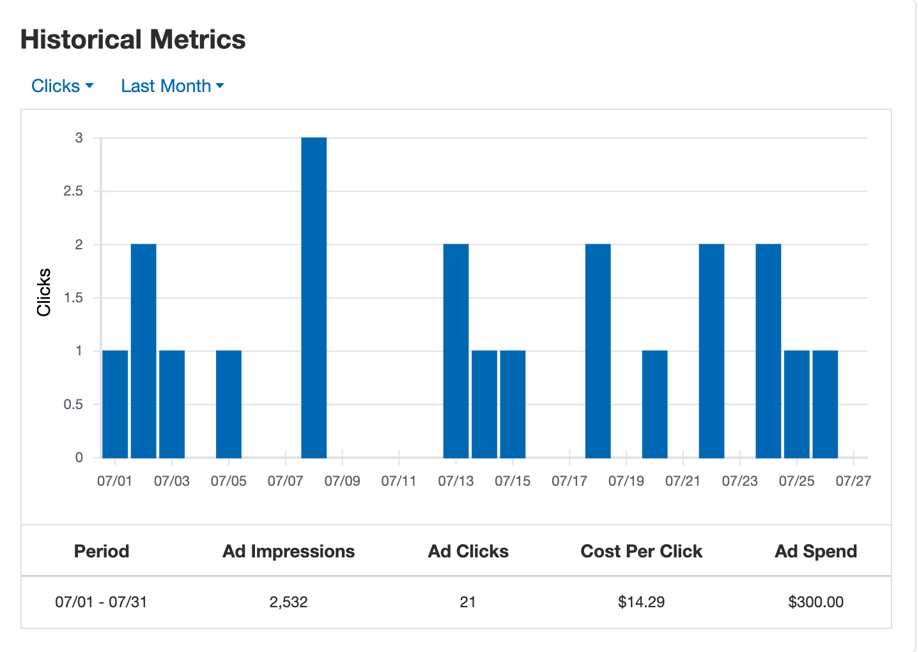

Strategy & Results from $300 Free Yelp Ads Trial
As you can see from the graphs in the ‘Historical metrics’ section above, these were our actual results from a campaign performed July 1st, 2019 through July 31st, 2019, using the $300 free trial offered by Yelp.

Our campaign was active for 26 days before the $300 free trial budget was completed. The strategy we selected for ad spend was a $10 per day budget for Yelp’s general targeting, with an additional $3 per day budget for the business page upgrades (see below for definition).

We received 2,532 impressions and 21 ad clicks with a cost per click of $14.29. This resulted in two booked appointments for in-home consultation, and one closed sale valued at $2,200.

Our total sales of $2,200 divided by the $300 ad cost means that had we been paying for this campaign, our return on investment would have been 630% in revenue.

For reference, the amount of the sale received is consistent with average sales within our industry and is what we see from alternative marketing channels such as Google AdWords.

Our plan for Yelp moving forward
We feel Yelp has certainly provided us with a lot of value, and while we already use Google AdWords and Bing Ads for targeting keyword searches via internet browsers, Yelp provides access to a user base that may only be using the Yelp platform to search for businesses. And, even if they are using both a browser and Yelp to search, we feel it’s best practice to be in front of them in as many places as possible to gain authority and presence.

Our current budget for Google AdWords and Bing Ads is $1200 per month, and we’ve decided to continue using Yelp ads with a budget of $400 per month. As with any advertising campaign, we will continue to create new ad campaigns, A/B test, measure results, and increase or decrease budgets whenever and wherever necessary.

Conclusion
In conclusion, the purpose of this study was to study the overall experience of completing of a Yelp business profile, creating a Yelp advertising campaign, and executing & measuring the results of Yelp’s $300 Free Trial.

Experience creating a business profile: The overall experience of creating a business profile was very simple, and even if we do not pay for ads, we are still receiving value because we can be found organically when users are searching for a business in our industry.

Experience creating a Yelp advertising campaign: Creating a campaign was straightforward and pretty easy to complete and we feel it was really designed with simplicity in mind. You do not need to know anything about marketing to create an ad on Yelp (of course, you want to research best practices and look up examples to get the best results possible).

There were a lot of helpful recommendations and some unique ways to help your business stand out, like using Business Highlights or Portfolios.

They give you plenty of options for selecting a daily budget, and you can make your ad as advanced, or simple, as you’d like and your budget allows with the add-ons and upgrades.

One negative, and it’s a big one, is the formatting for the ad copy area of the campaign. All of the text runs together like one continuous paragraph, which makes it difficult to read and presents a challenge when writing copy. Hopefully, by the time you’re reading this, they will have updated the formatting issues. Until then, stick to one paragraph.

Tip: When you’re writing your ad copy, keep it clear and to the point, and always ask the user to take an action, such as contacting you.

Executing & measuring the results of Yelp’s $300 Free Trial: Once the campaign was live, we tweaked the budget a few times to increase the speed at which the budget would be depleted.

The metrics they provide are industry standard and definitely help to understand what is happening with your campaigns.

We made sure to ask every client who contacted us where they found us, and included Yelp as an option on our contact form (‘how did you find us’ is a required field on our contact form). Additionally, we used a different phone number on our Yelp profile so that if someone called us manually (i.e. didn’t click our number on the Yelp ad itself) we would instantly know they found us via Yelp without even asking.

The results definitely impressed us. We expected to get a few leads and hopefully book a couple consultations. Many prospects have a longer sales life cycle, meaning they may contact us initially, but not make a reservation for several months. We were happy to see that one of the consultations we booked did hire us immediately and we generated $2,200 from that lead.

